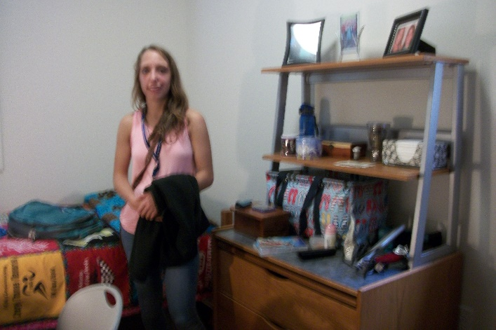

To place a picture of your drawing on your storyboard:
- Practice a rough draft of each of your drawings.
- Create a final copy of each of the drawings.
- Take a picture of each drawing using an Ipad or phone.
- Save both to separate google docs.
- Save both to separate Word documents.
- Return to Discovery Education.
- Upload your pictures onto the storyboard.

